**Assignment_4**

**====================================================================**

**Name:** Ahmed Nour

**Sheet ID:** 16

**Email:** [**ahmedmohamednoour@gmail.com**](mailto:ahmedmohamednoour@gmail.com)

**====================================================================**

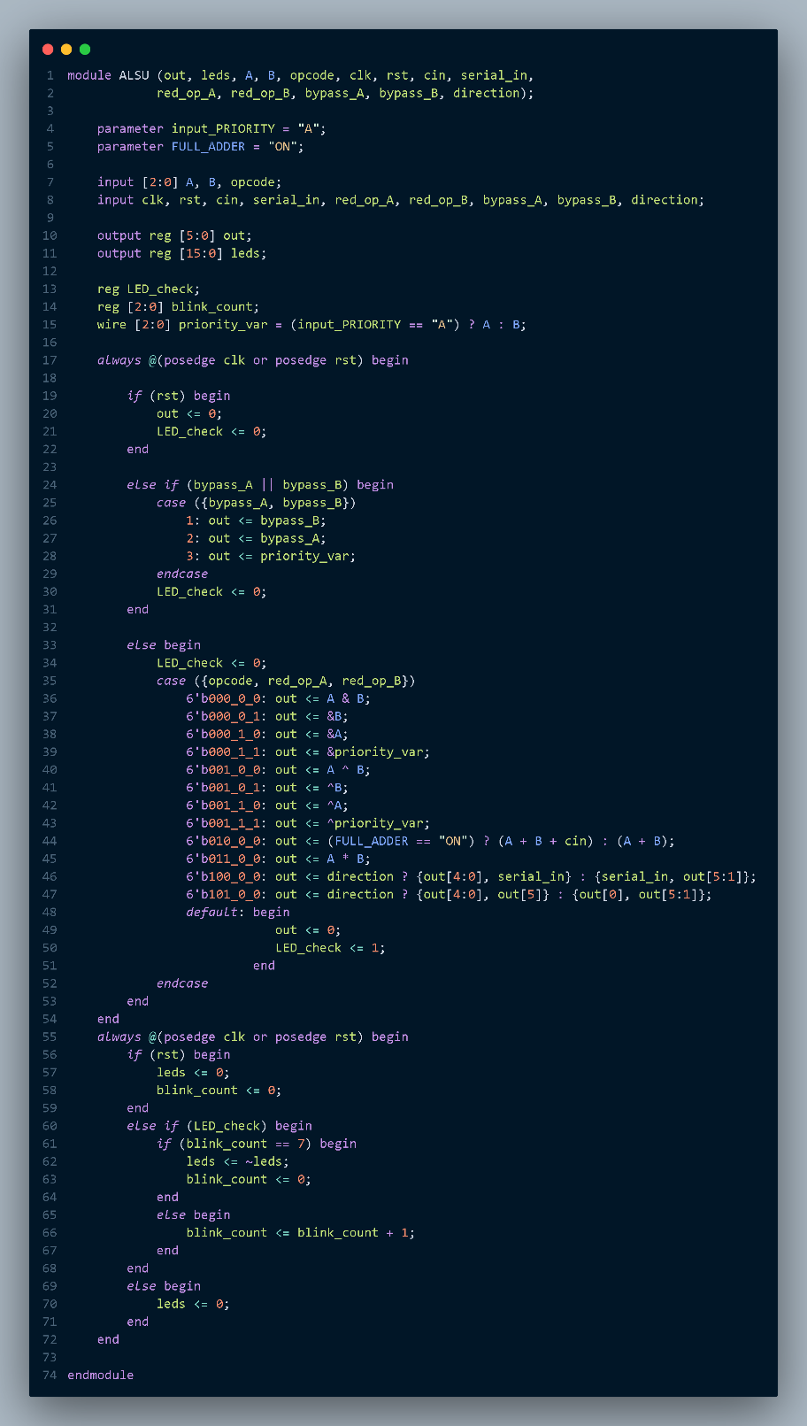**Q1)**

**Verilog code:**

1. **RTL design:**
2. **Testbench code:**

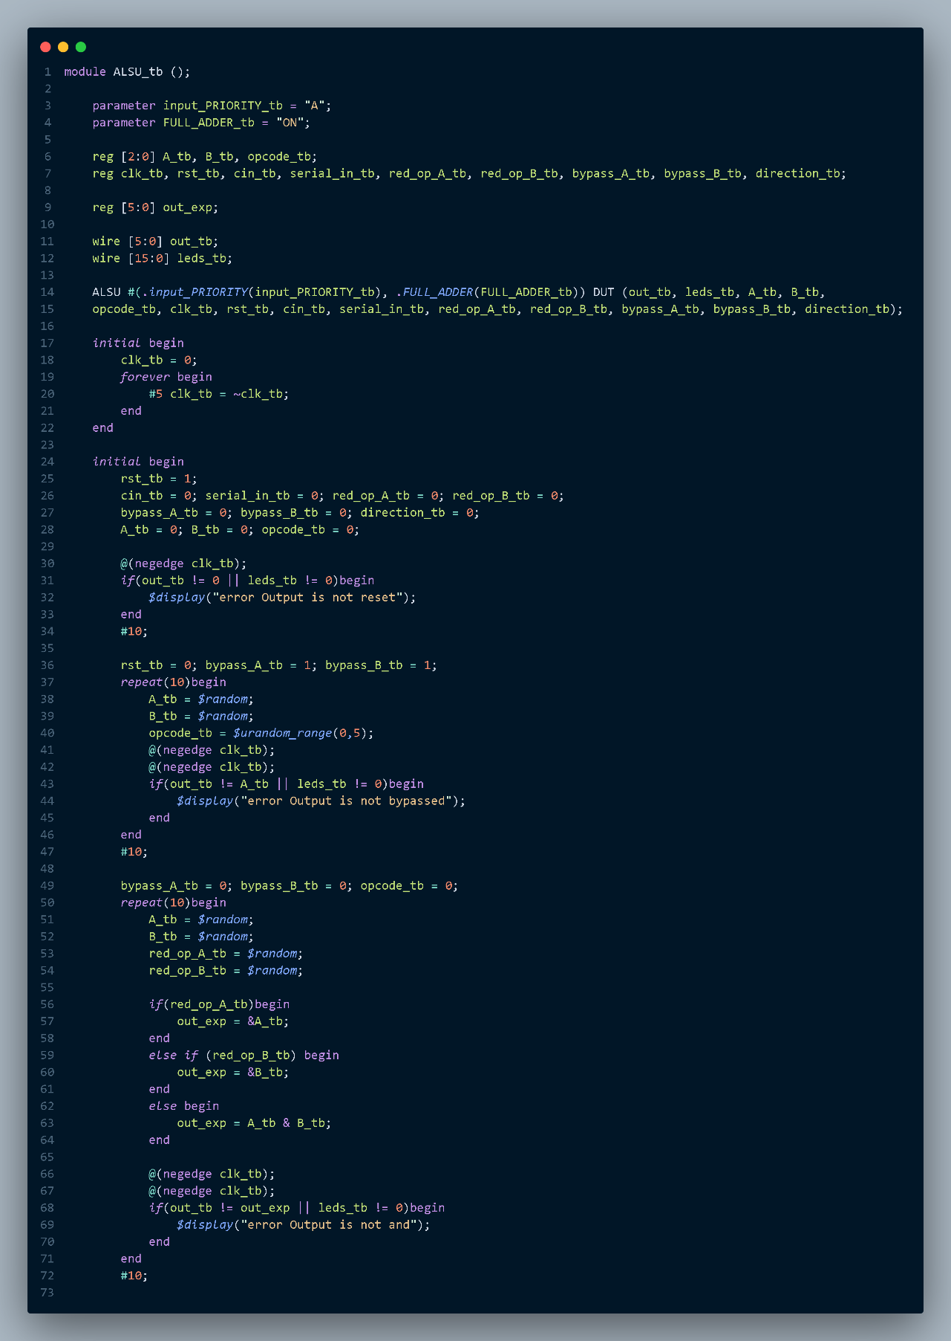

**//rest of code in next page**

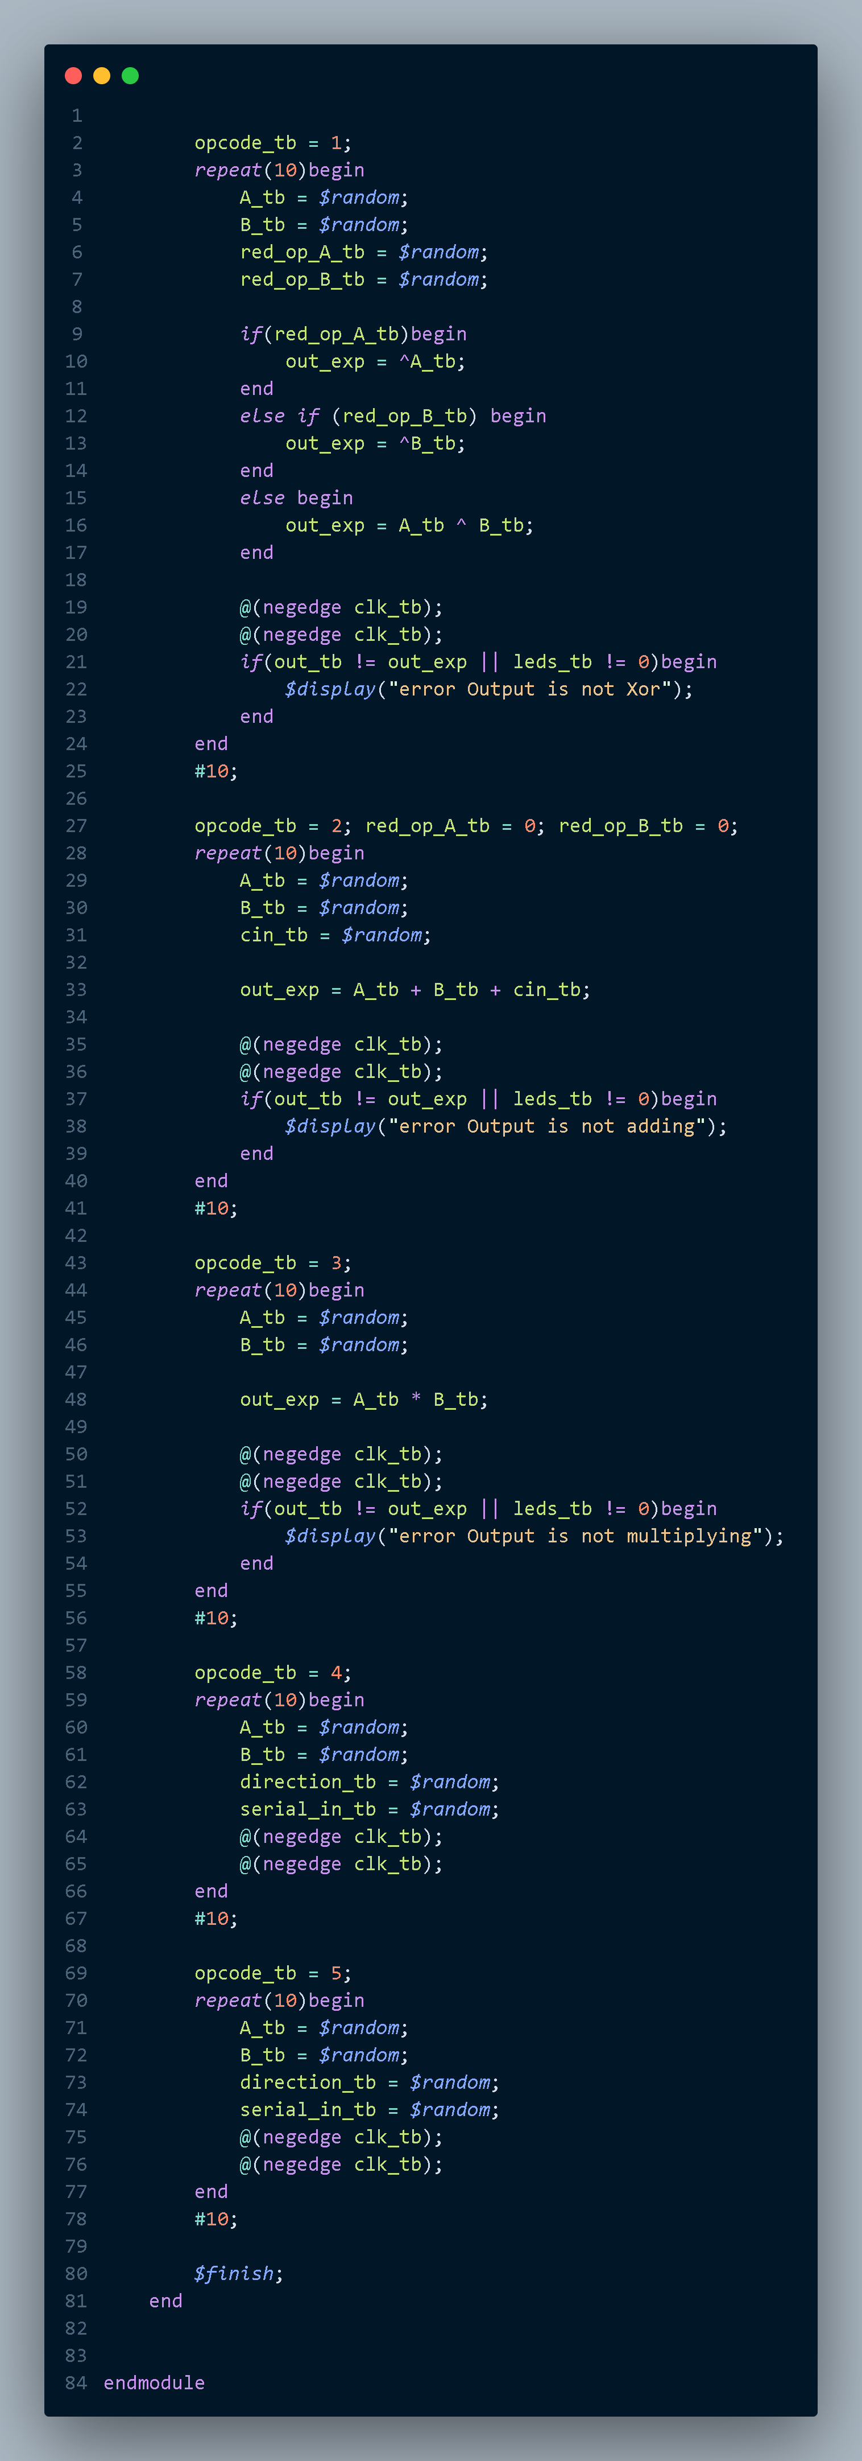

**Simulation Tool**

1. **Do file**

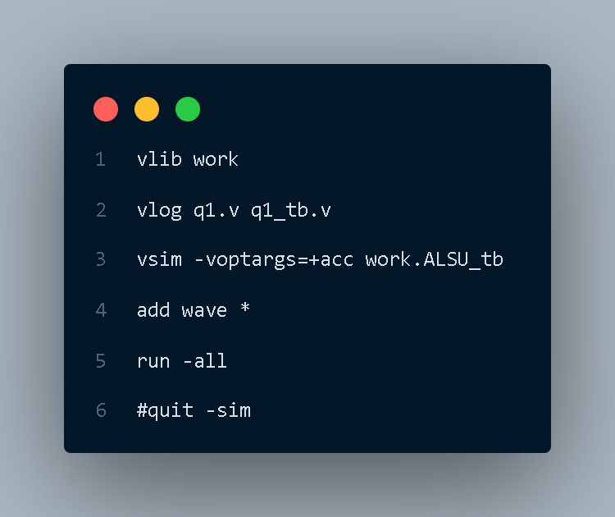

1. **Questasim**

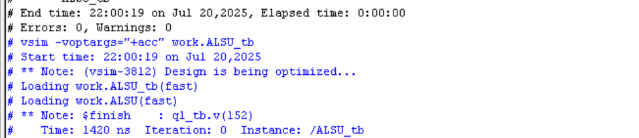

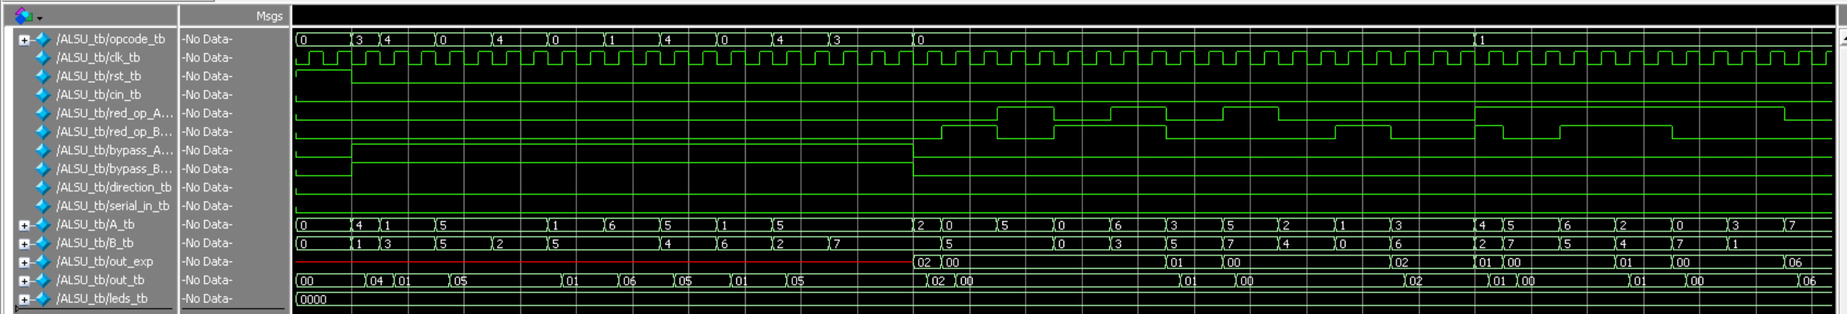

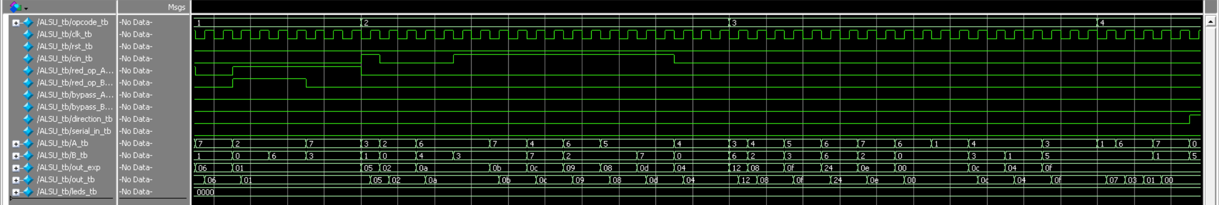

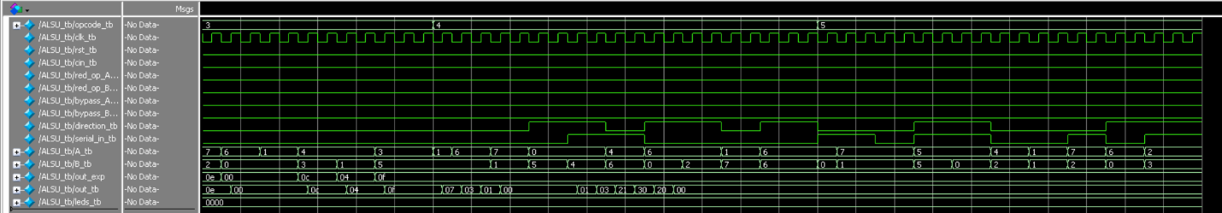

**Synthesis Tool:**

1. 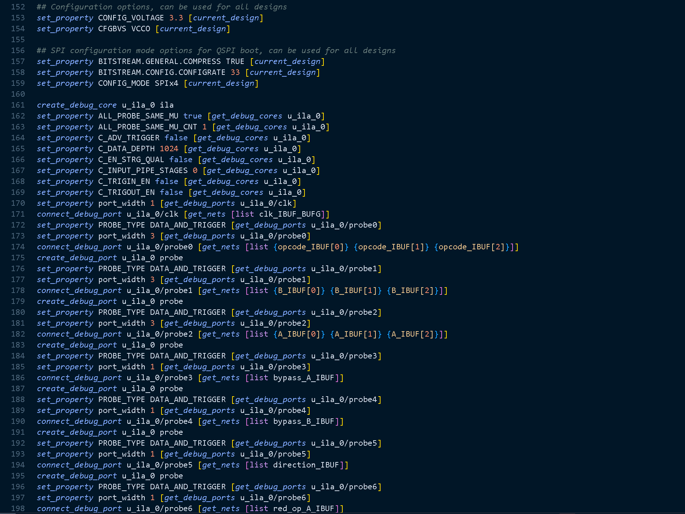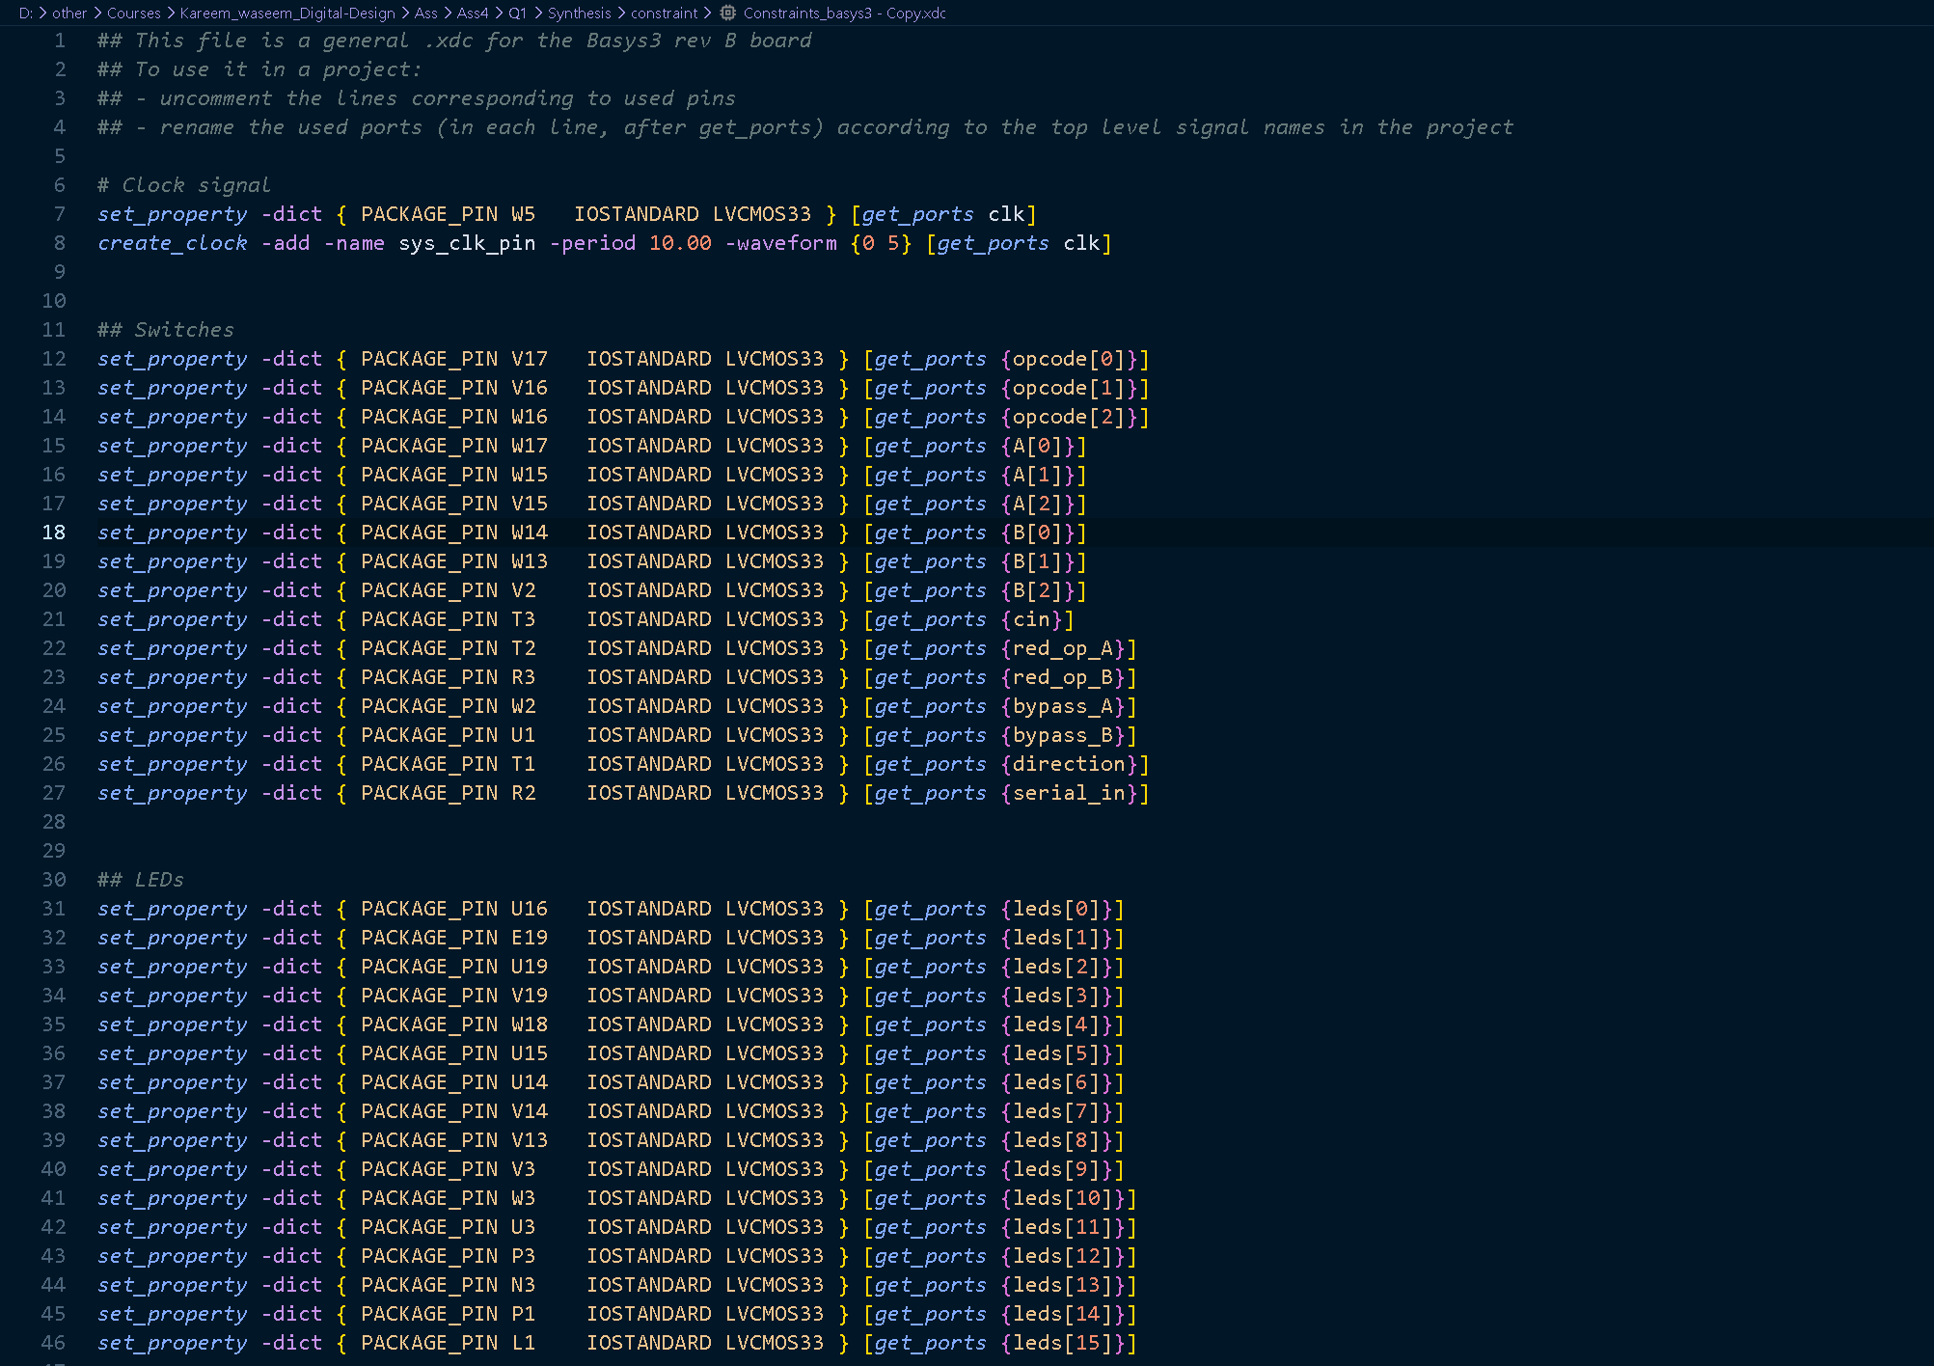**Constraint file**

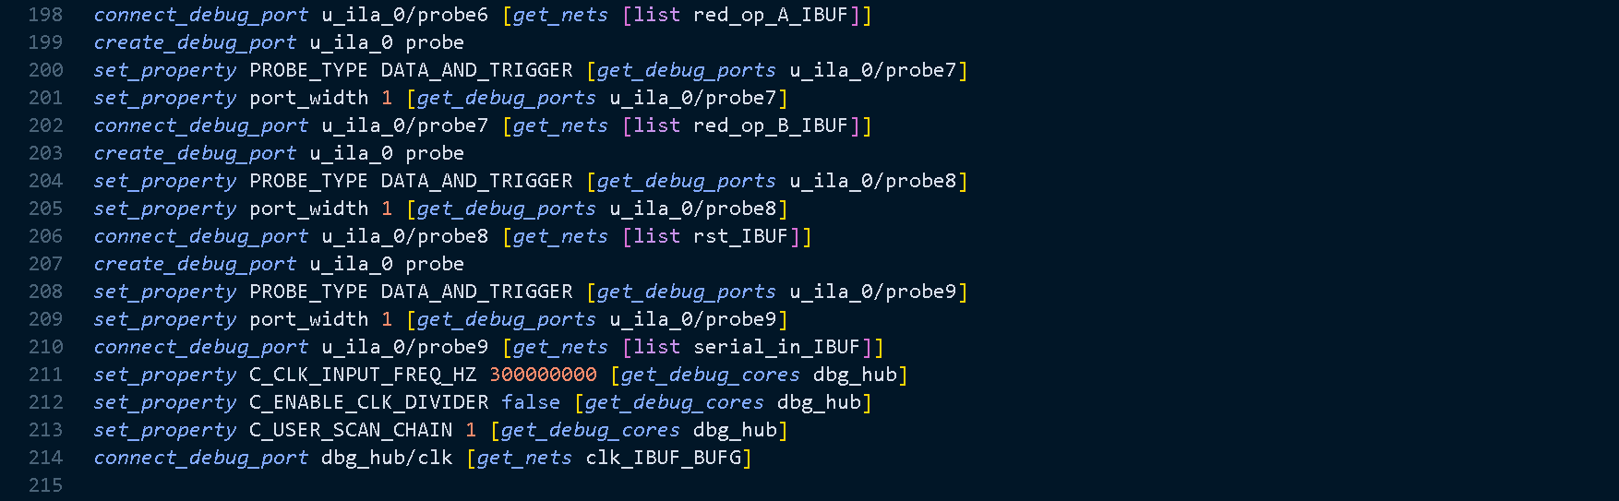

1. **Elaboration**

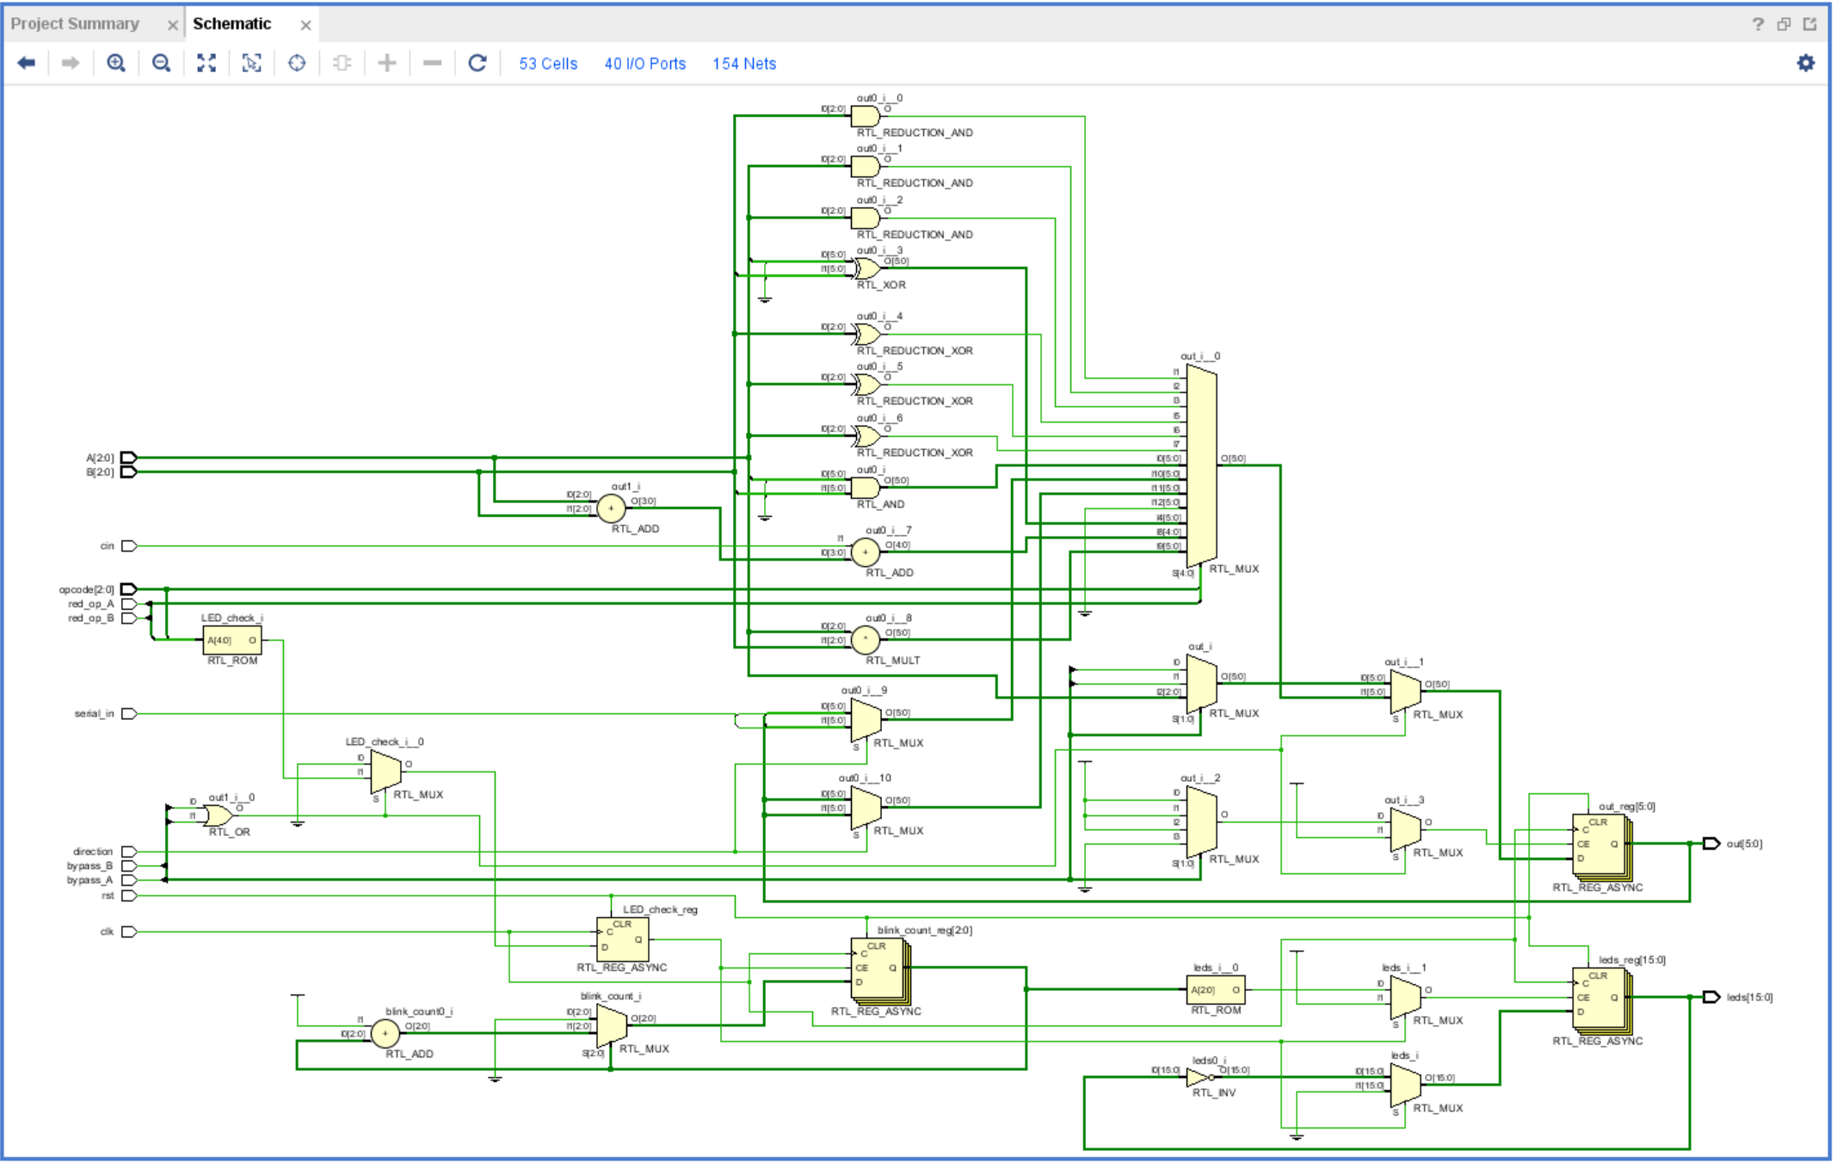

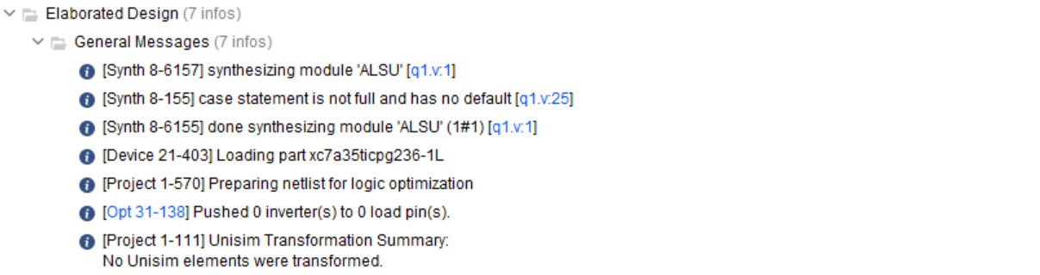

1. **Synthesis**

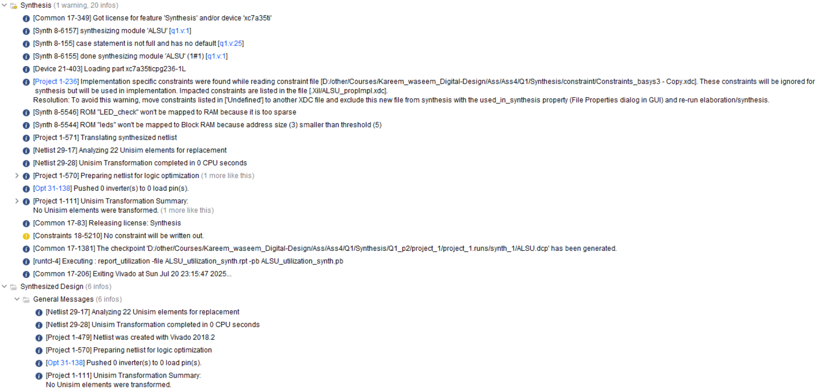

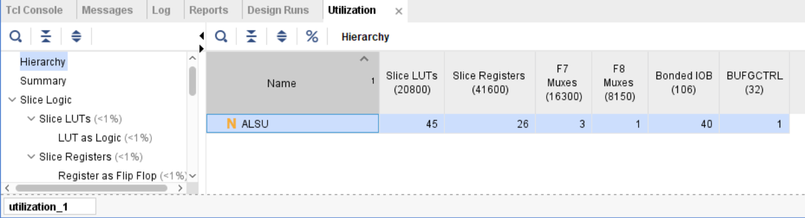

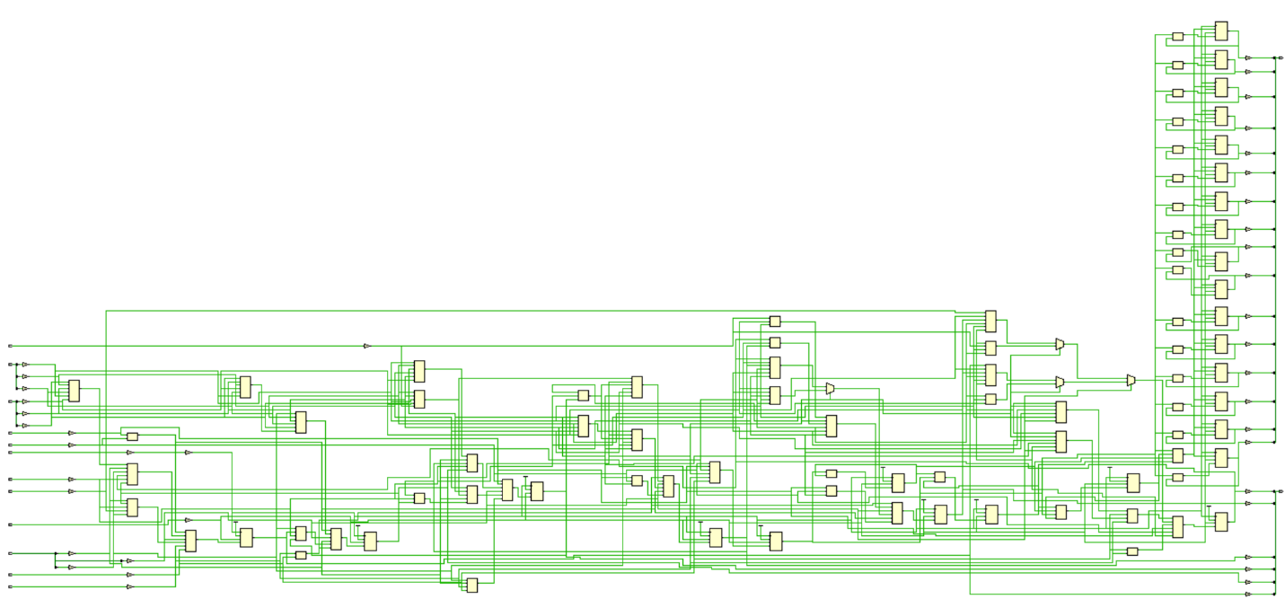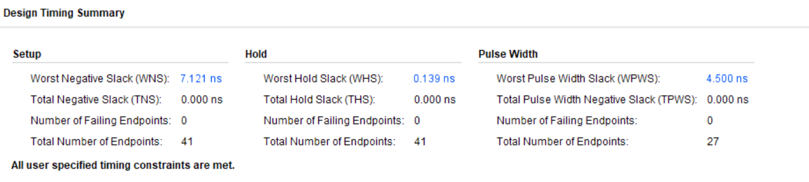

1. **Implementation**

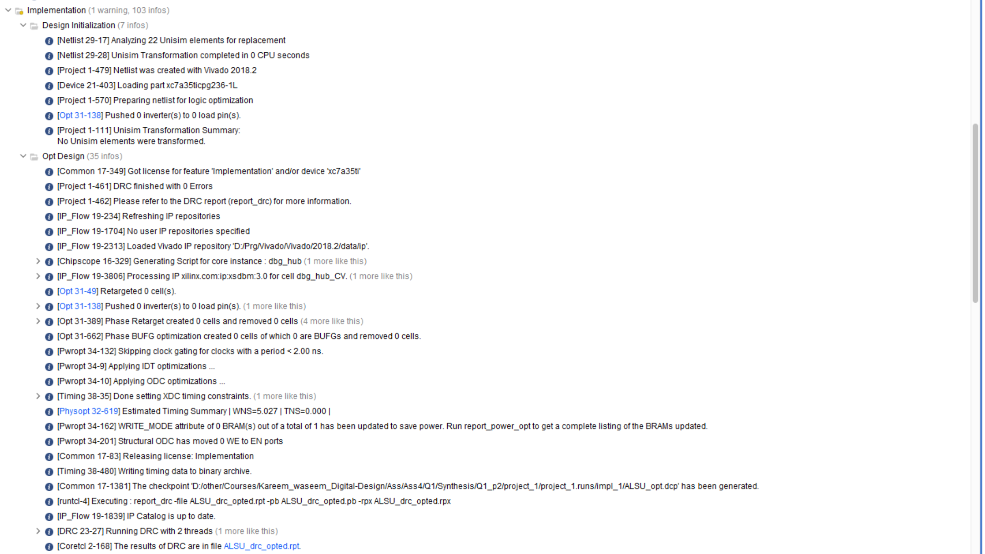

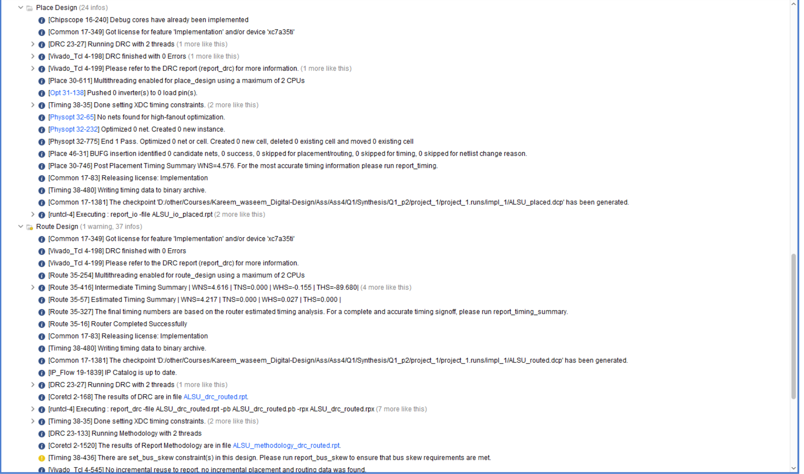

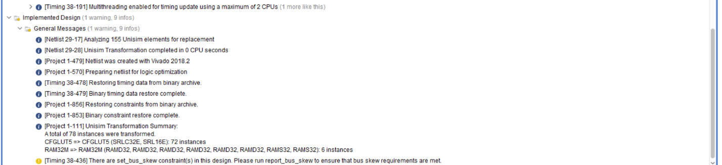

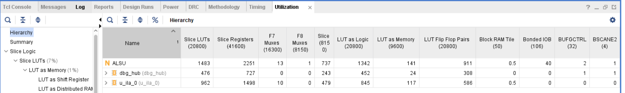

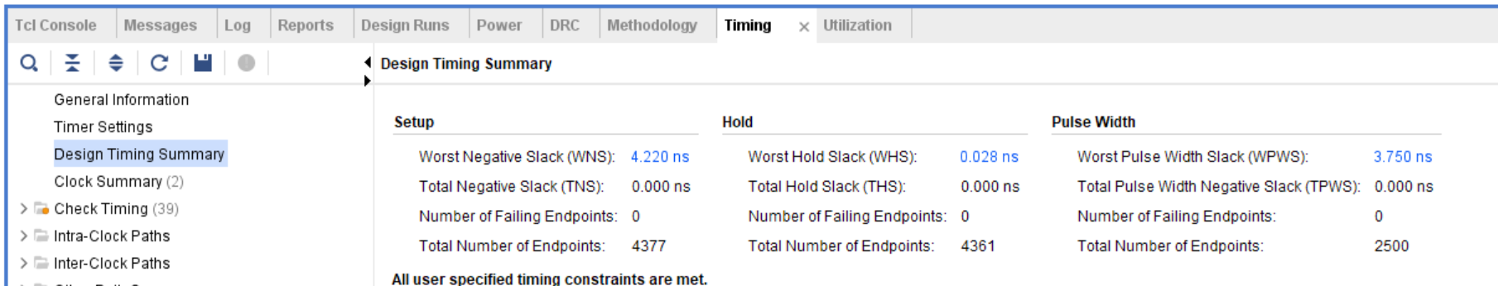

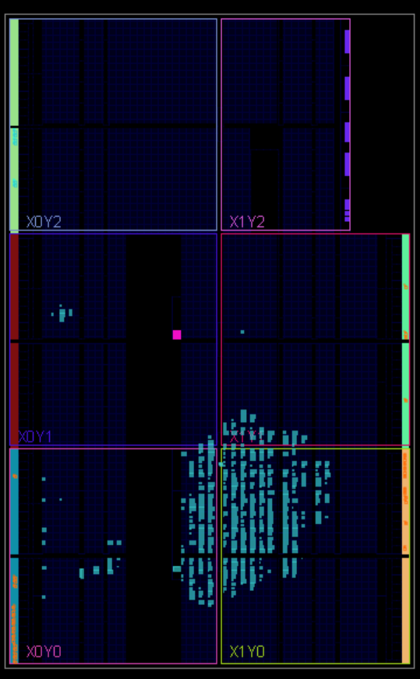

**Linting Tool**

**a)**

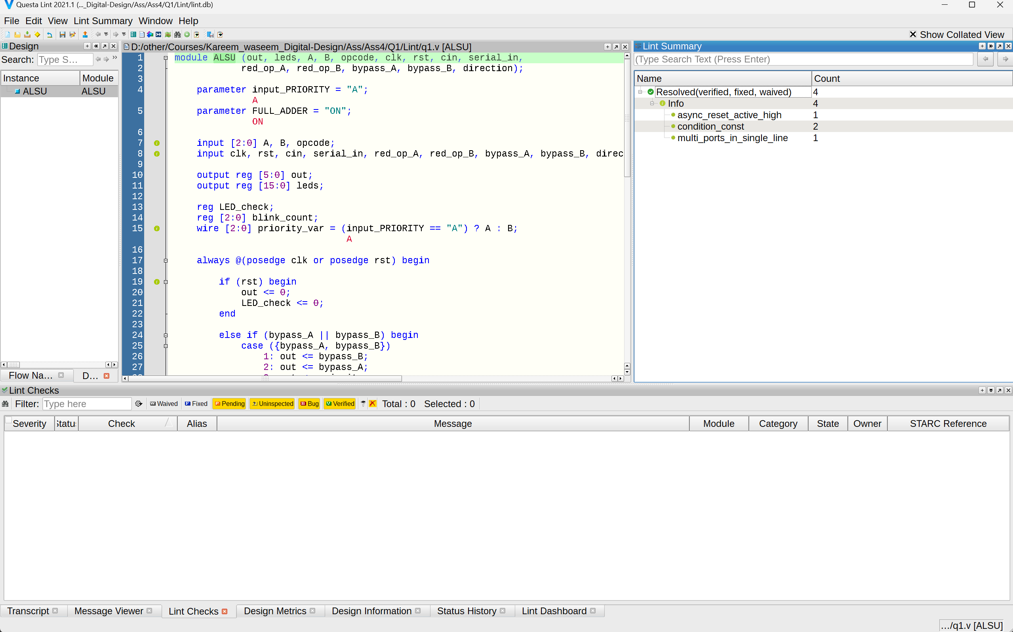

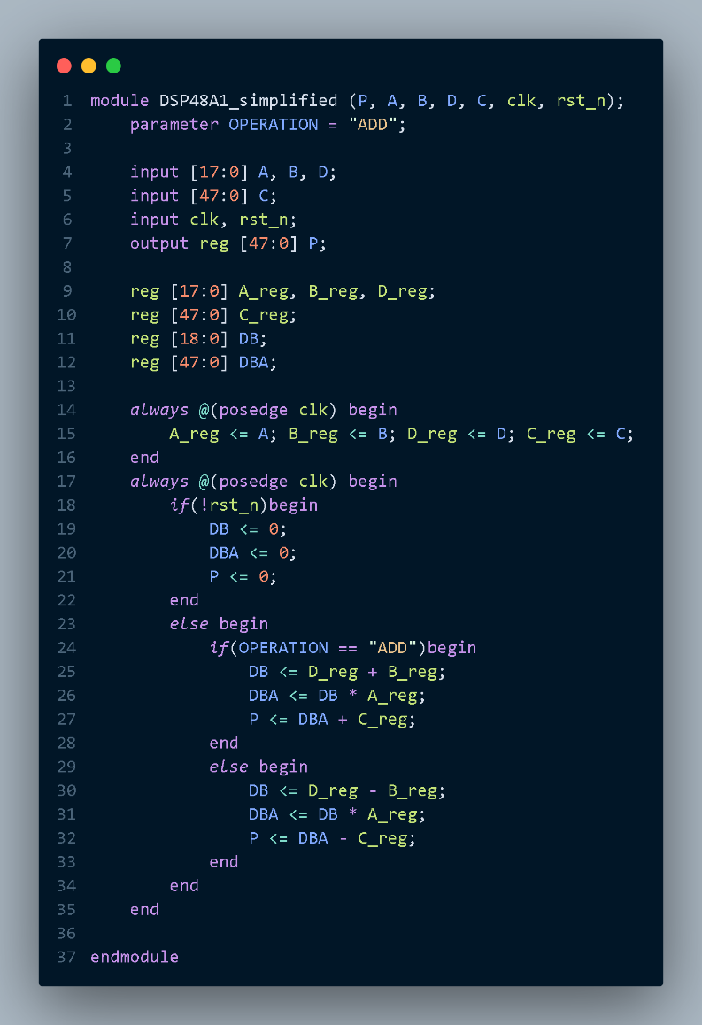**Q2)**

**Verilog code:**

1. **RTL design**

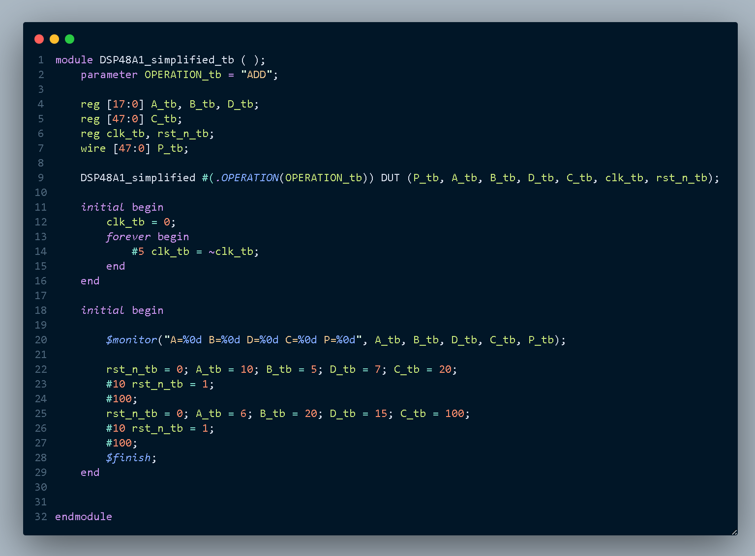

1. **Testbench:**

**Simulation Tool**

1. **Do file**

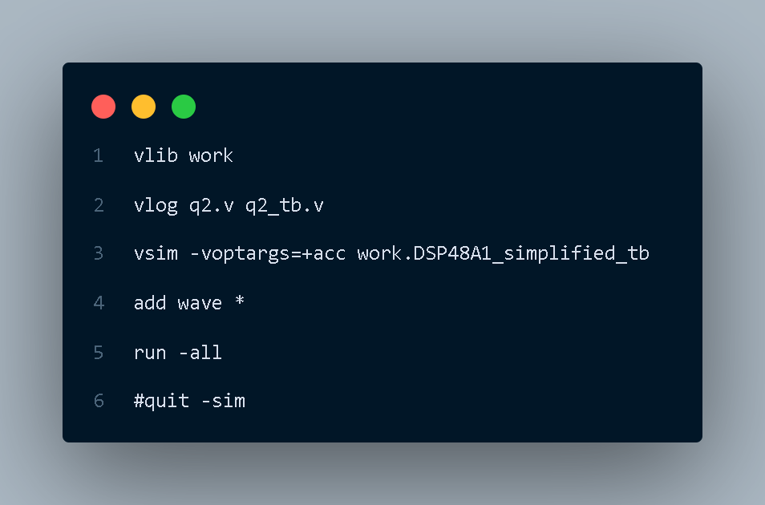

1. **Questasim**

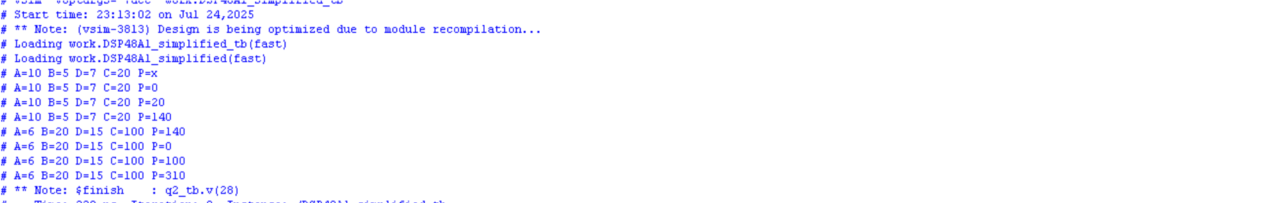





**Synthesis Tool:**

1. **Constraint file**

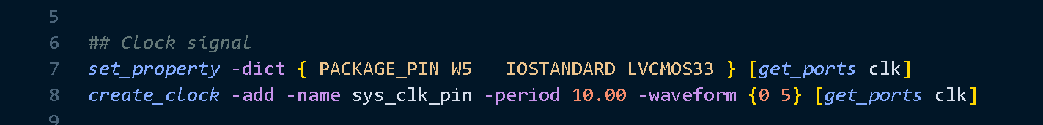

1. **Elaboration**

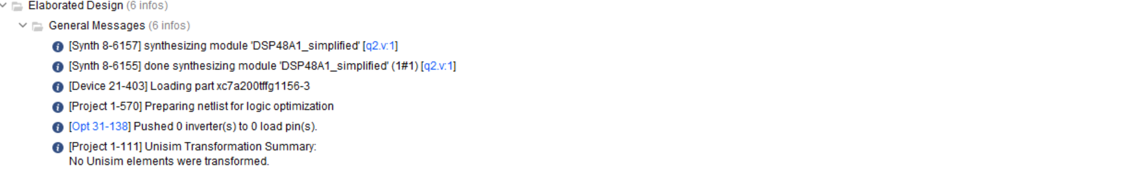

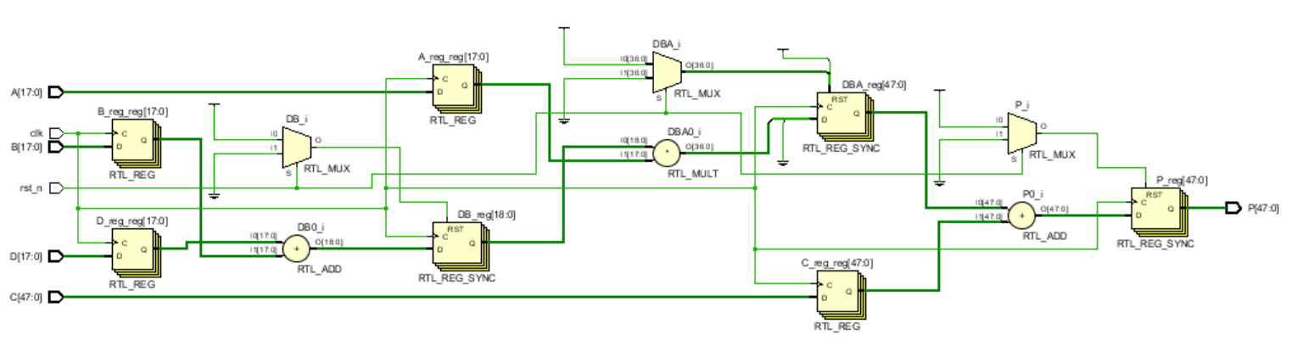

1. **Synthesis**

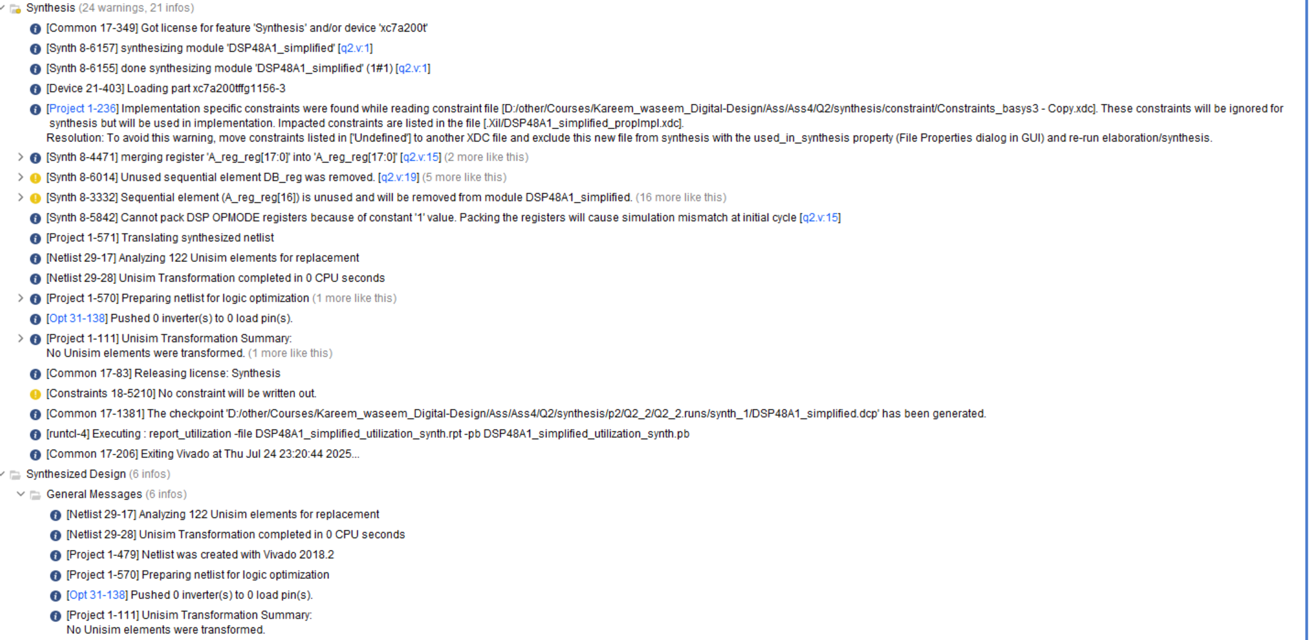

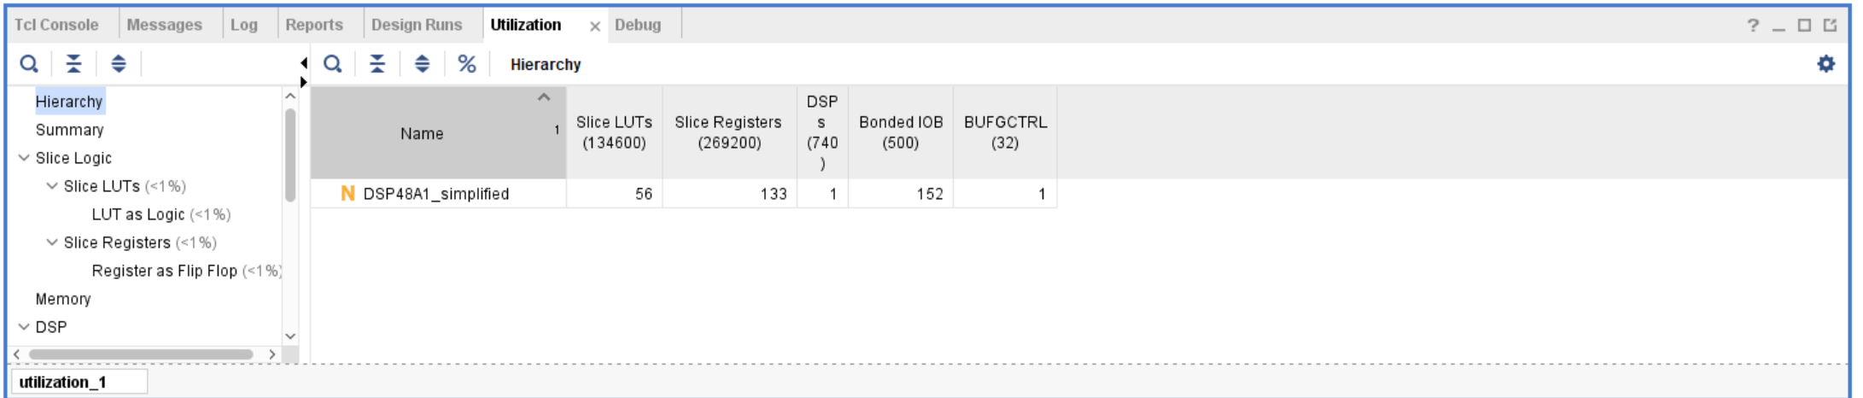

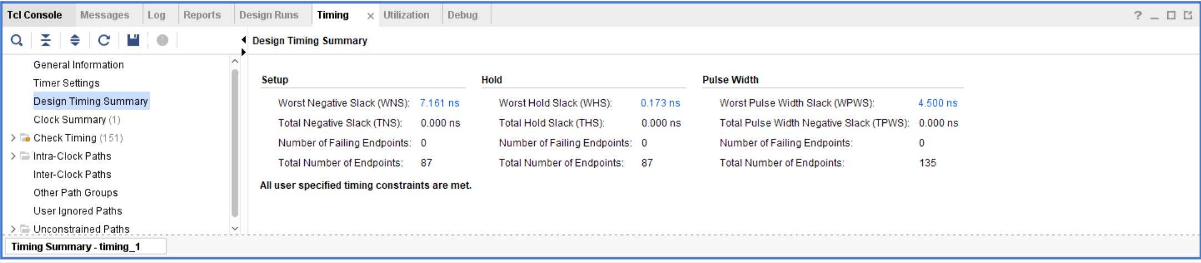

**Synthesis schematic:**

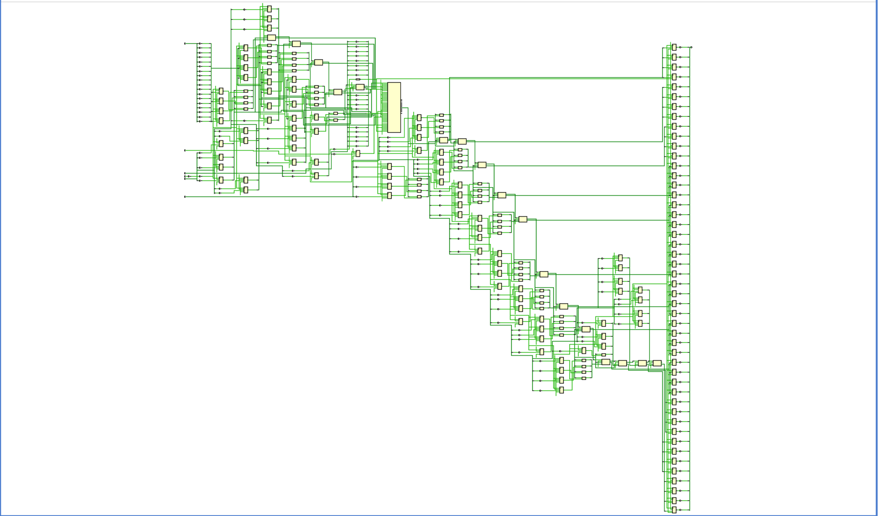

1. **Implementation**

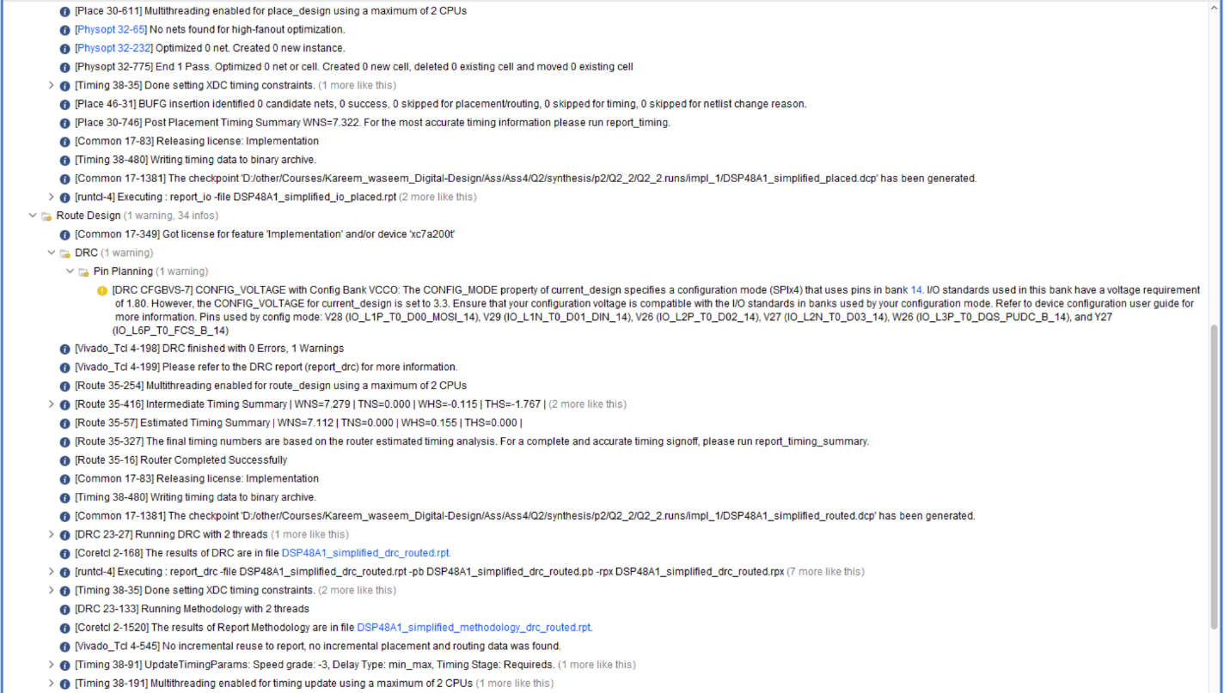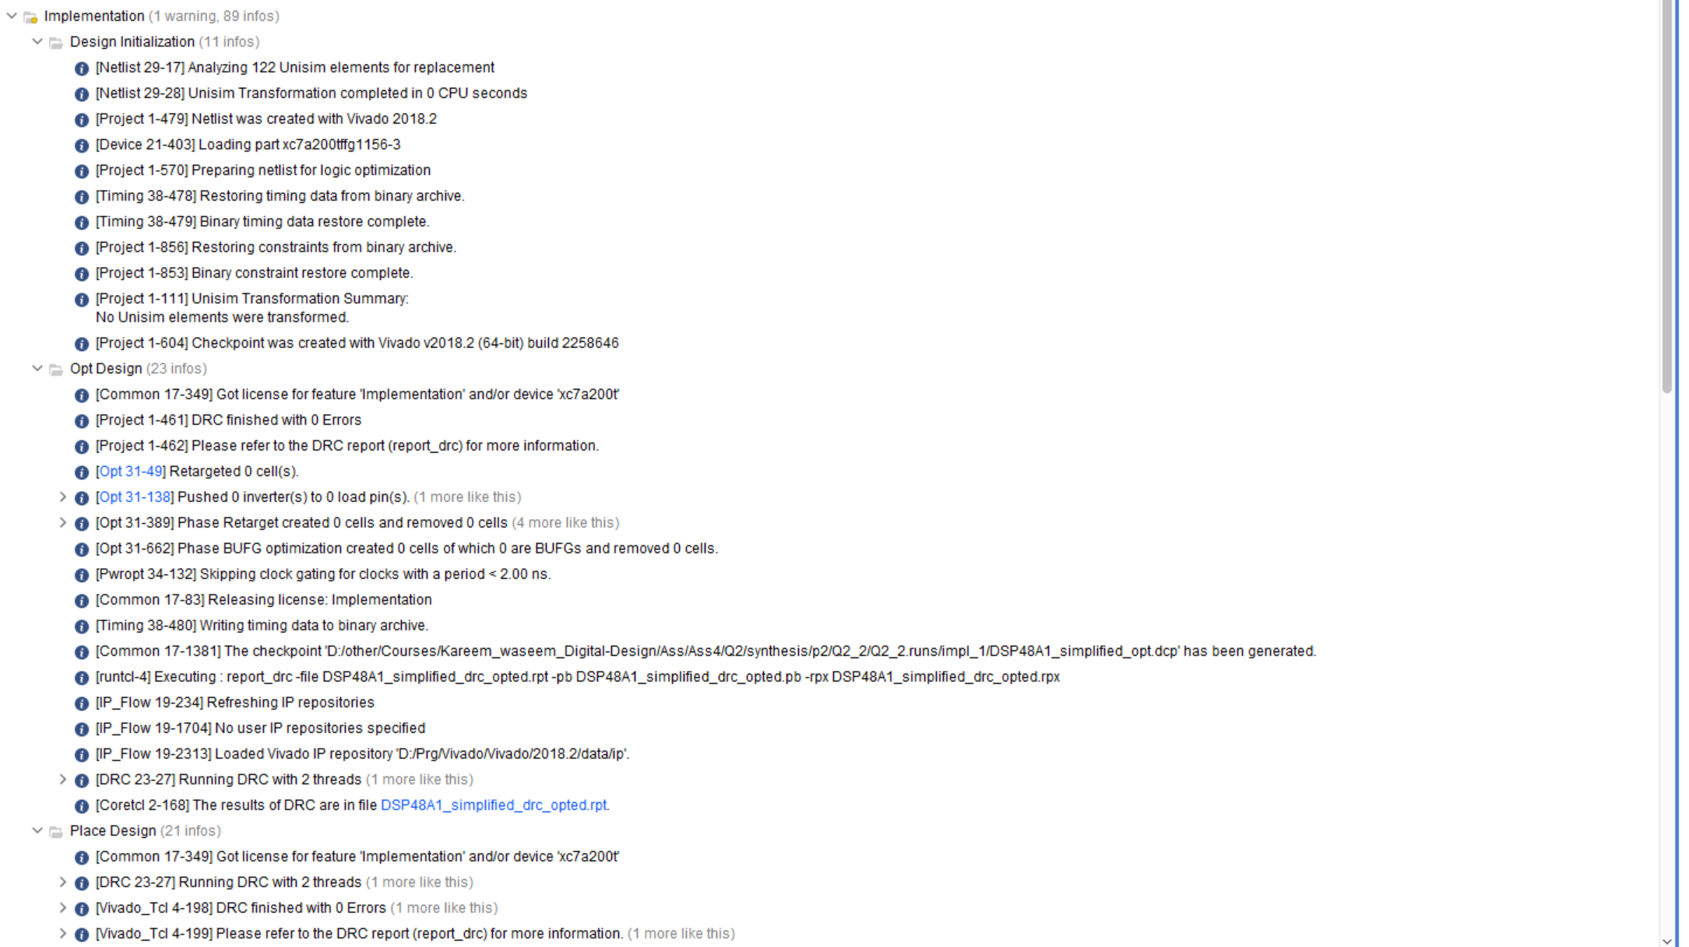

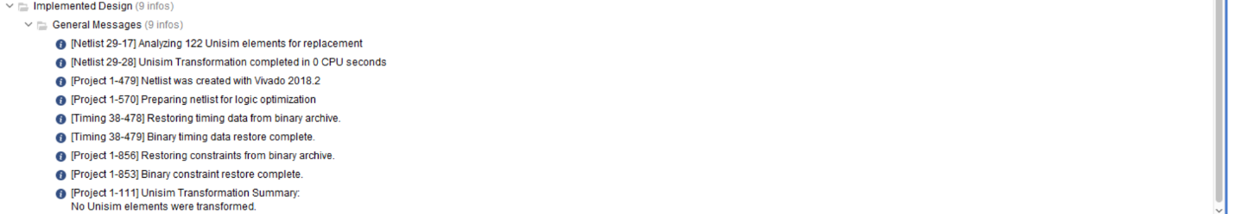

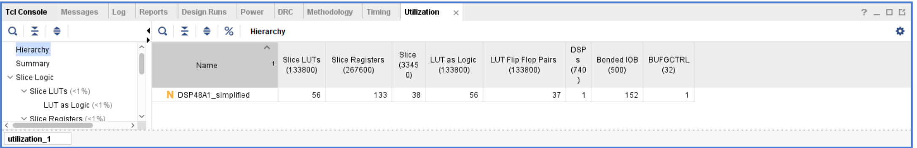

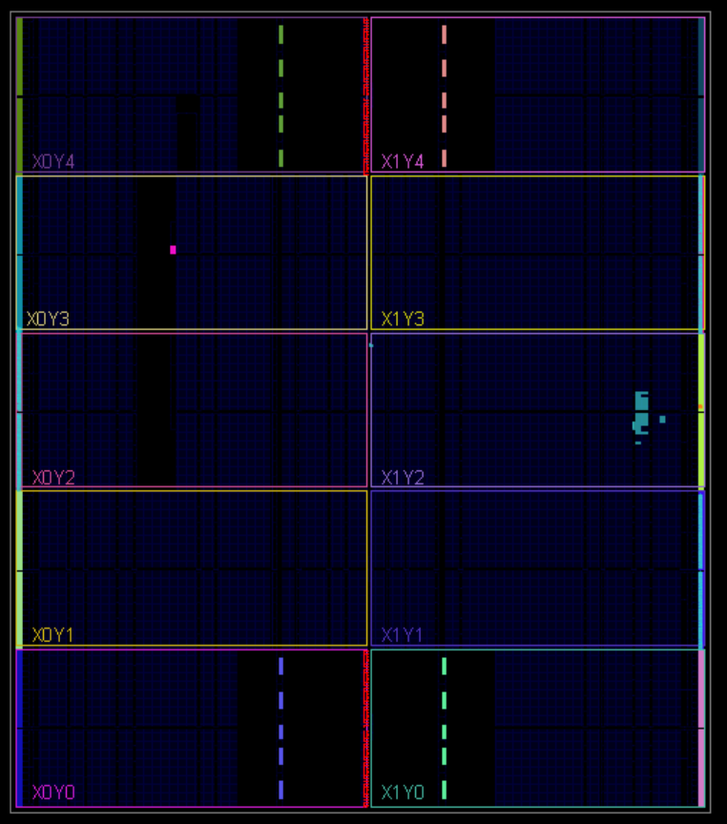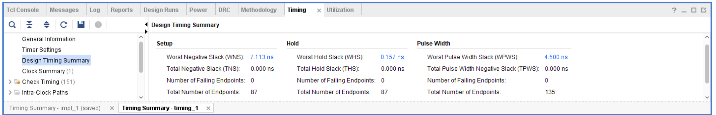

**Linting:**

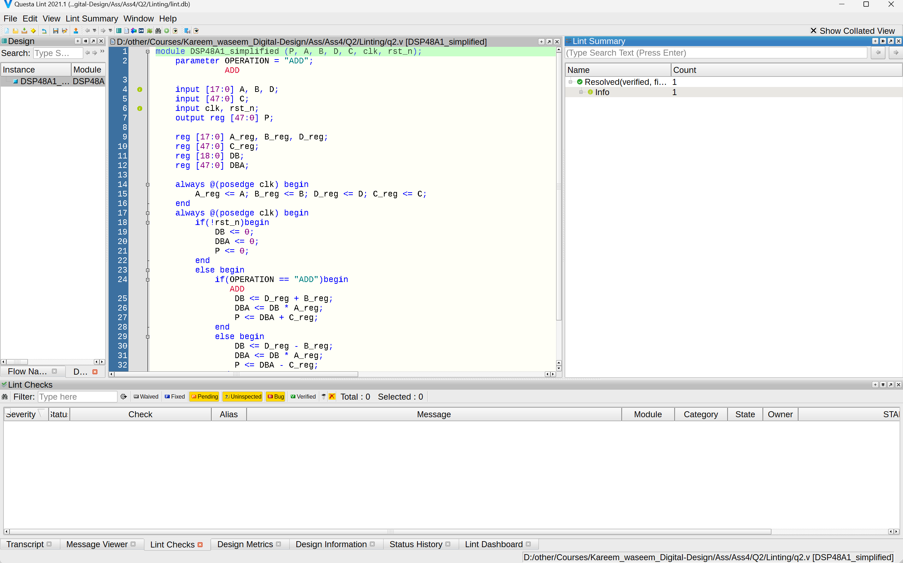

**Q3)**

**Verilog Code:**

1. **RTL design**

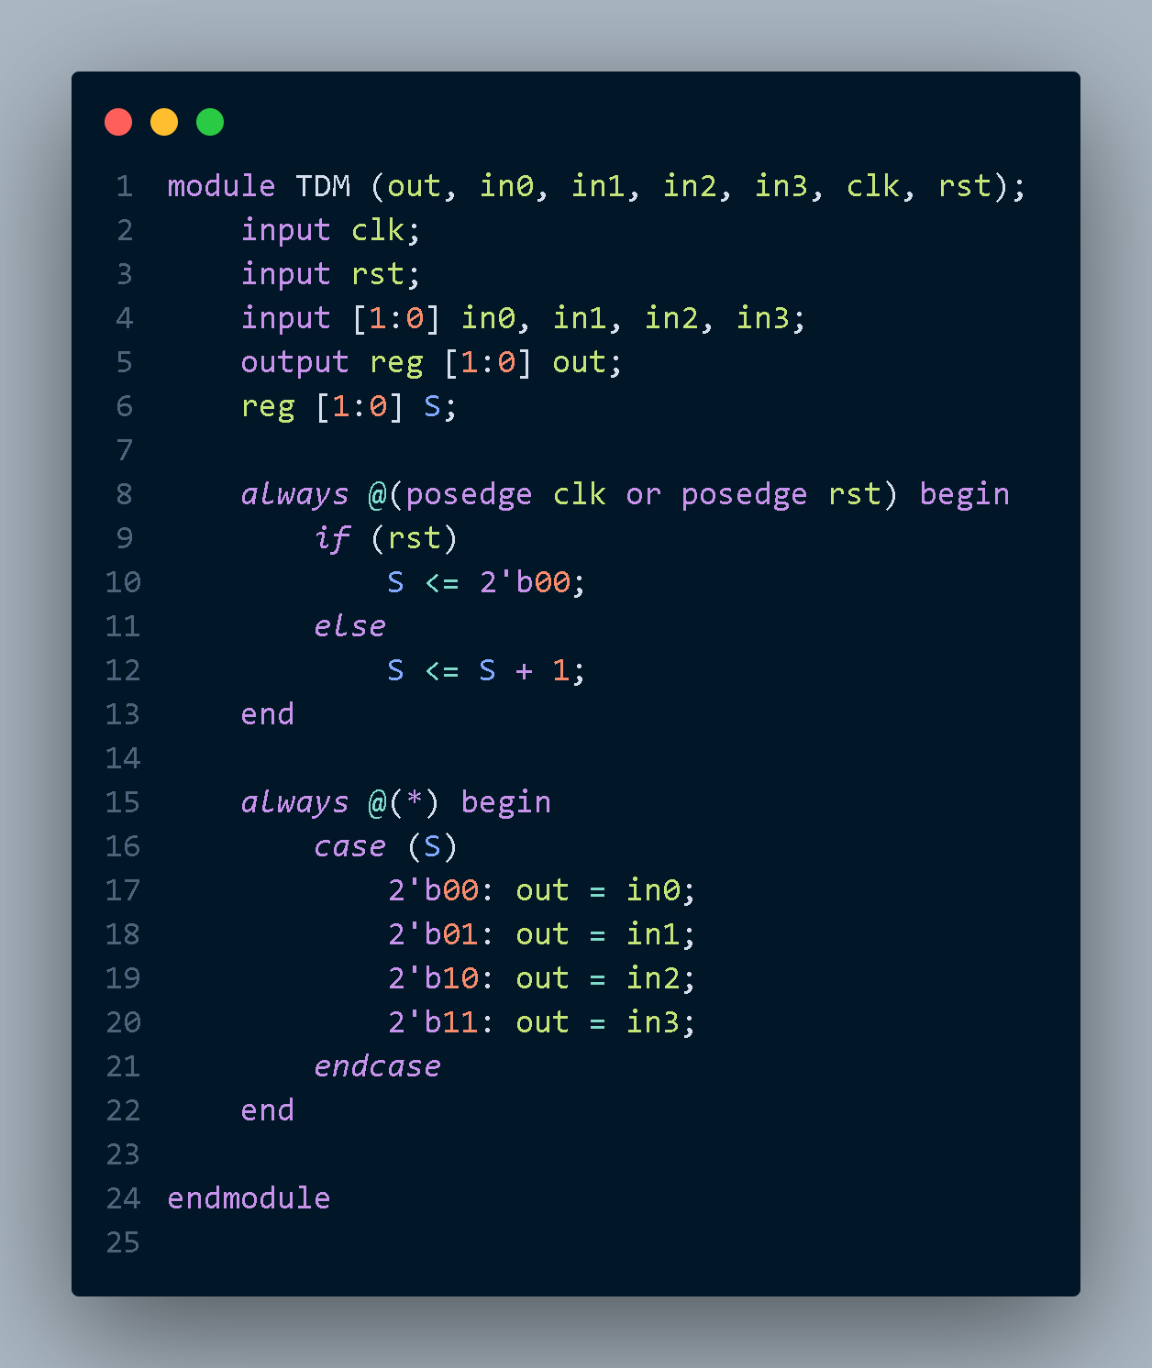

1. **Testbench**

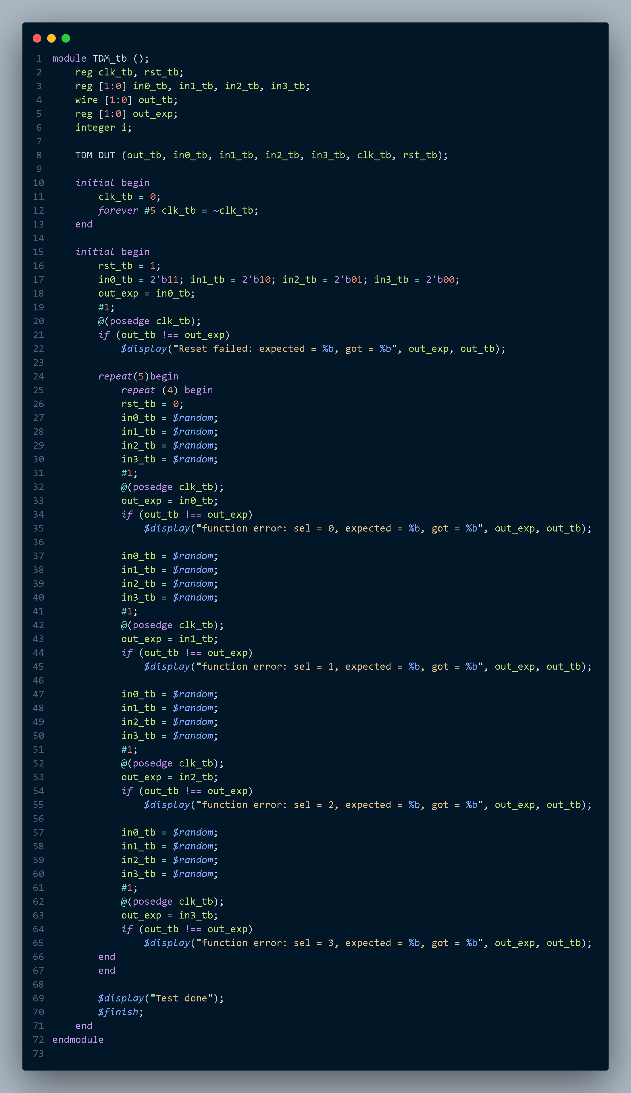

**Simulation Tool**

1. **Do file**

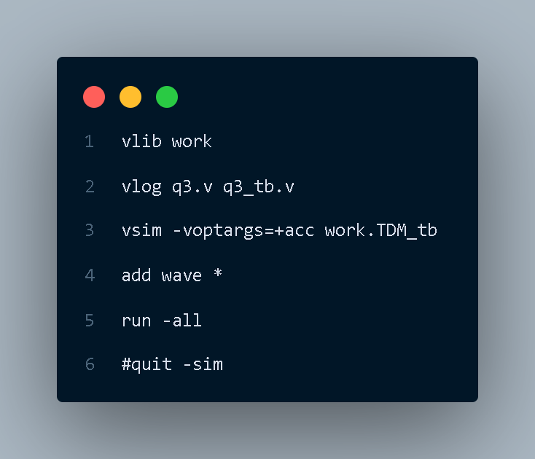

1. **Questasim**

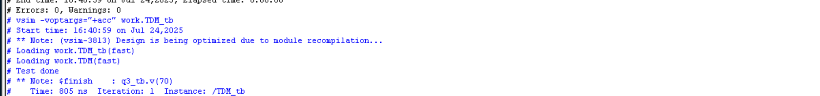



**Synthesis Tool:**

1. **Constraint file**

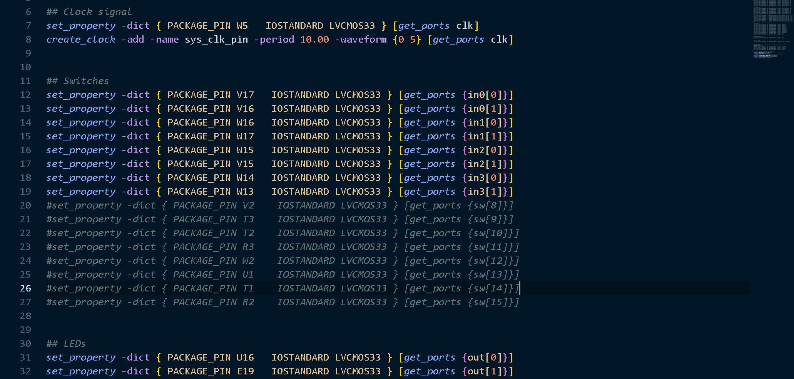



1. **Elaboration**

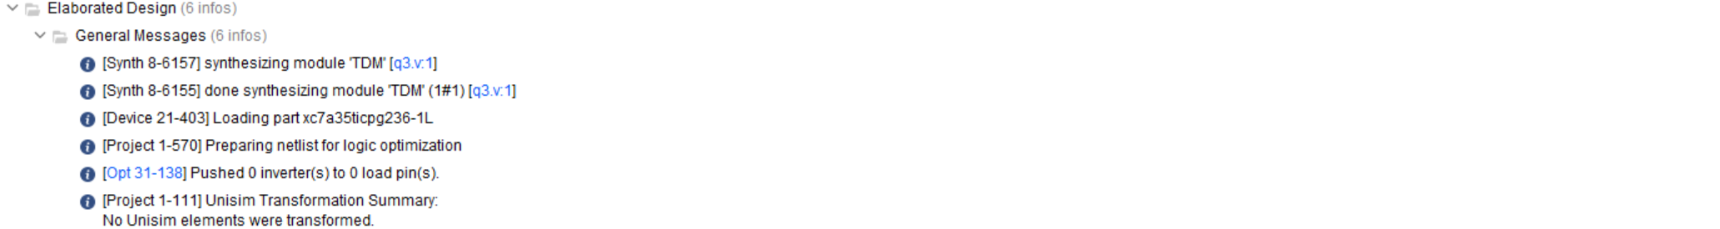

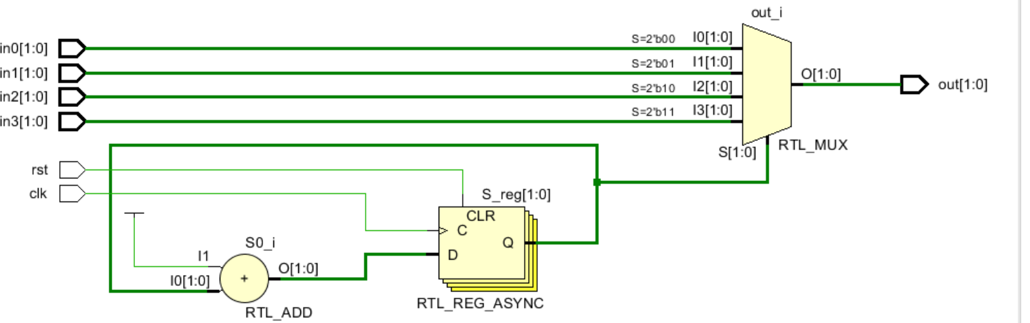

1. **Synthesis**

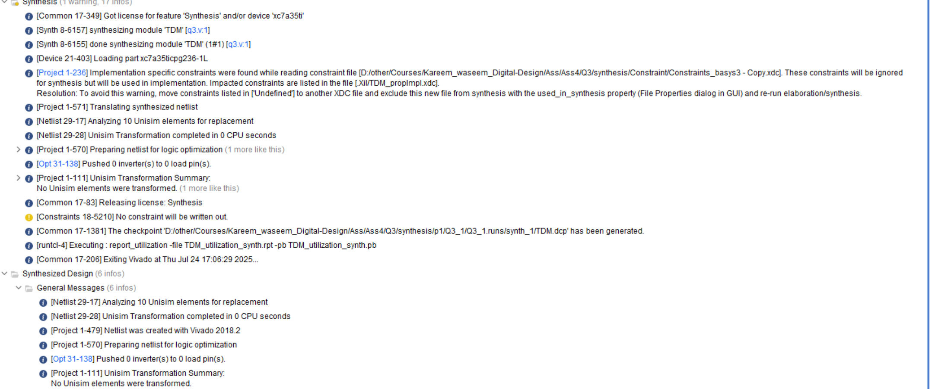

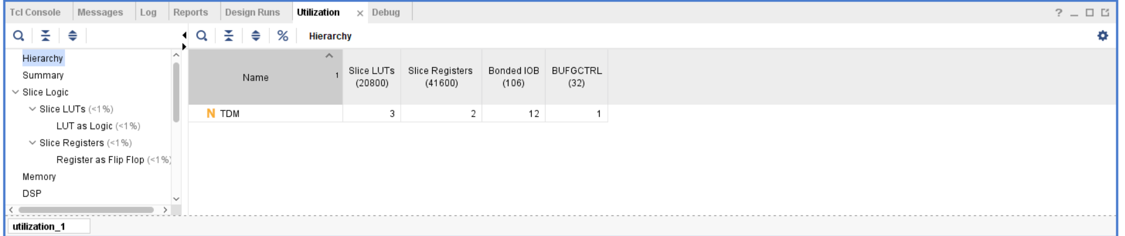

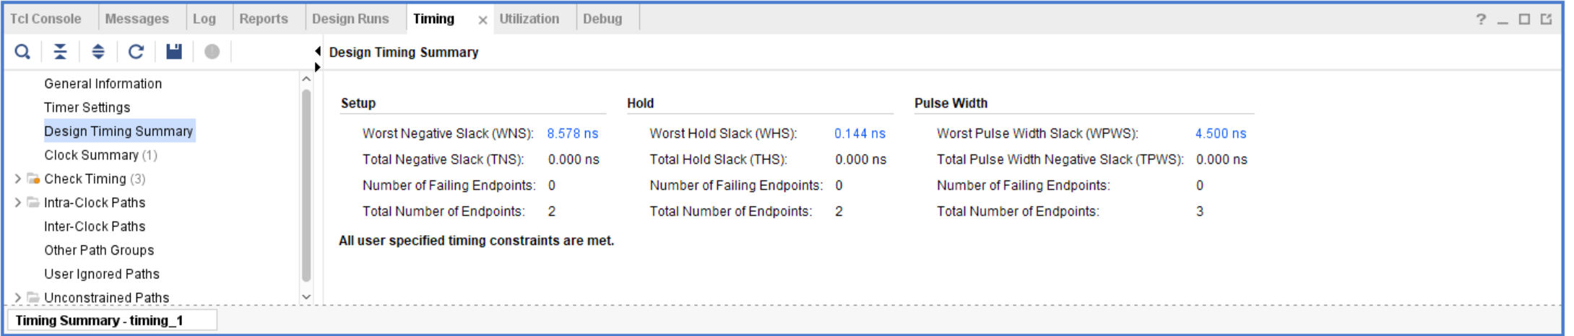

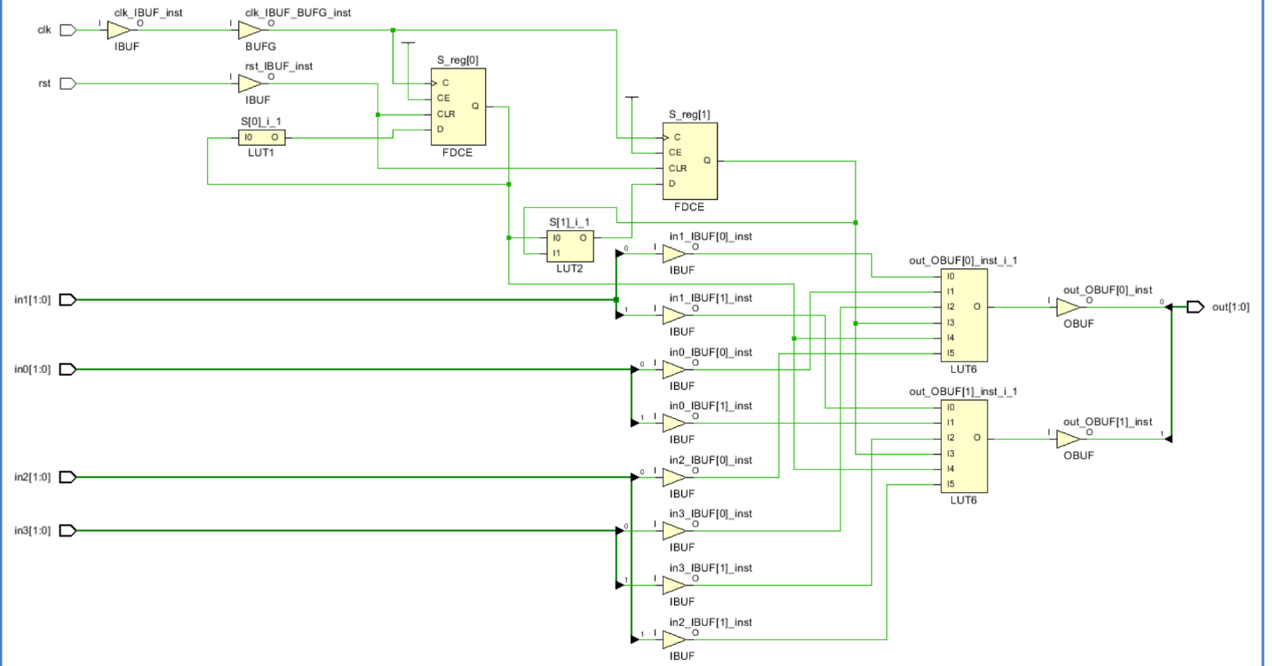

1. **Implementation**

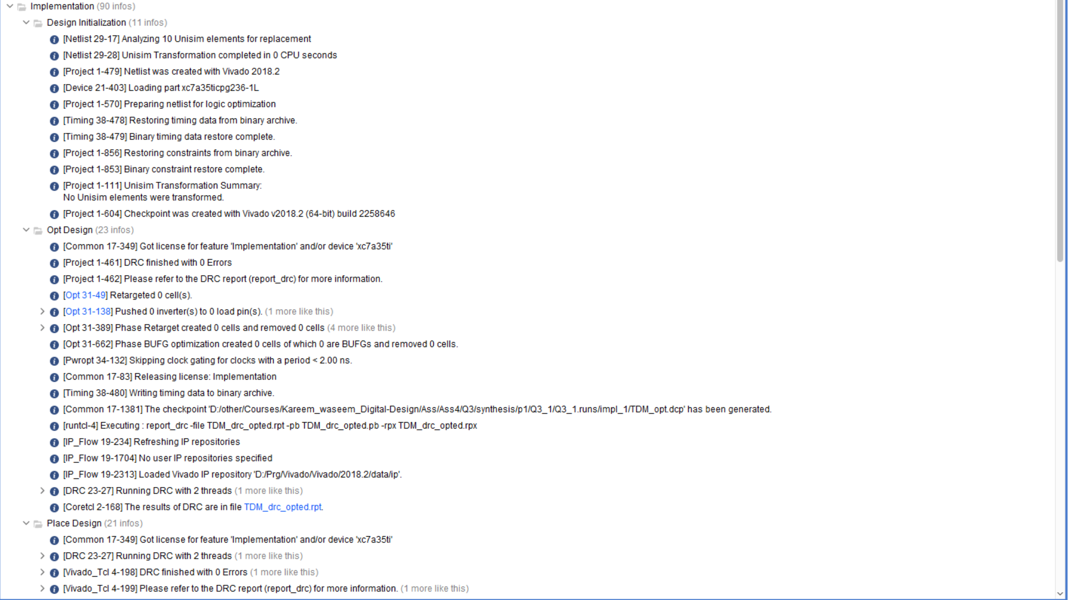

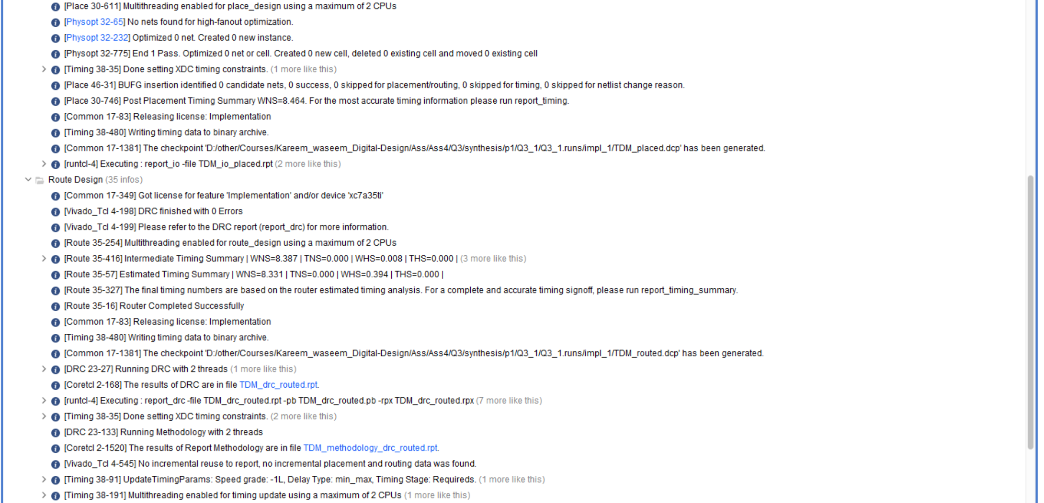

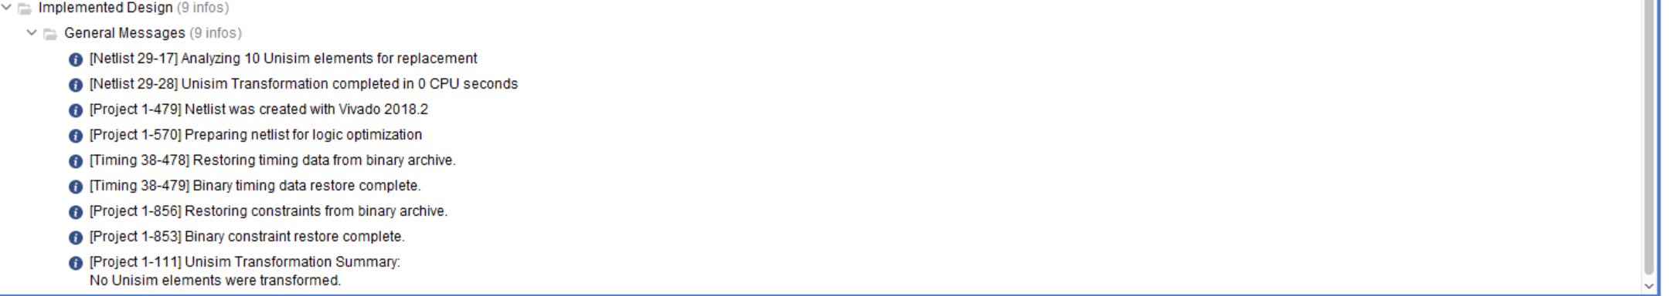

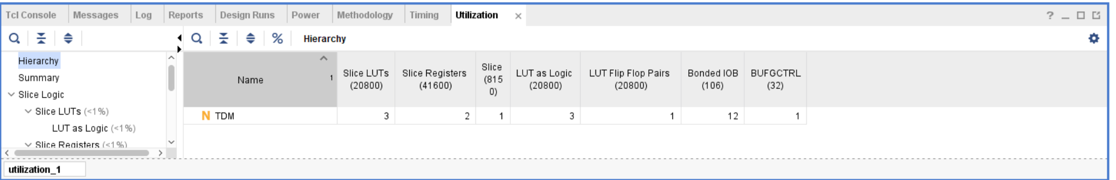

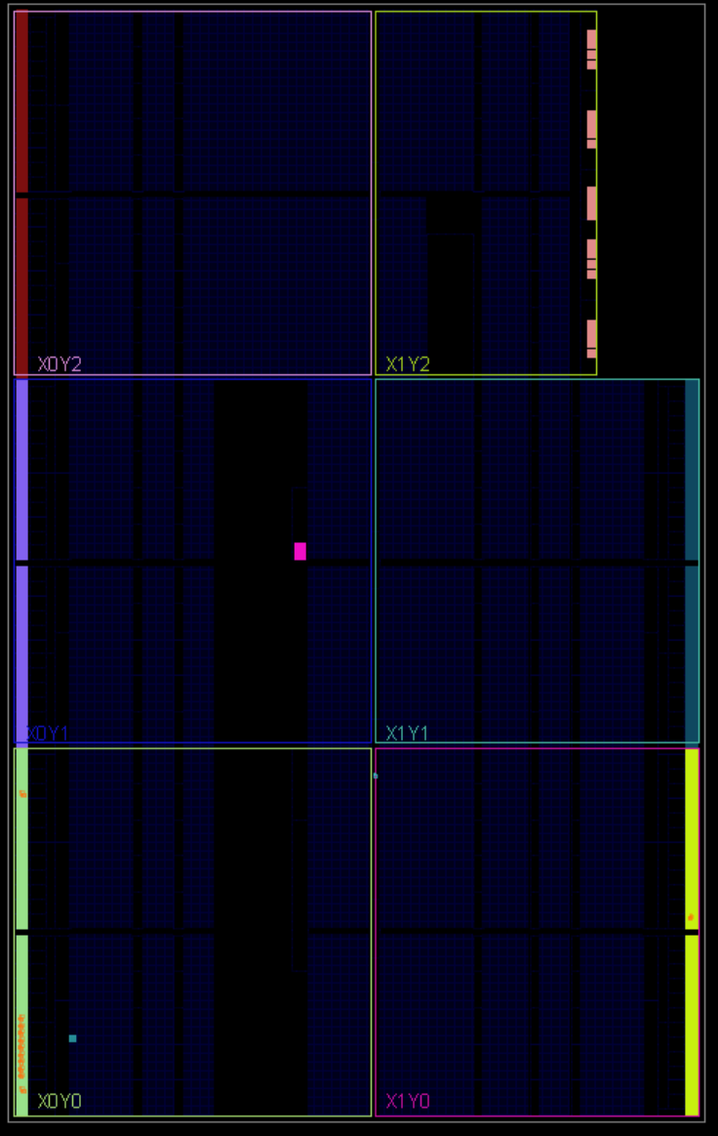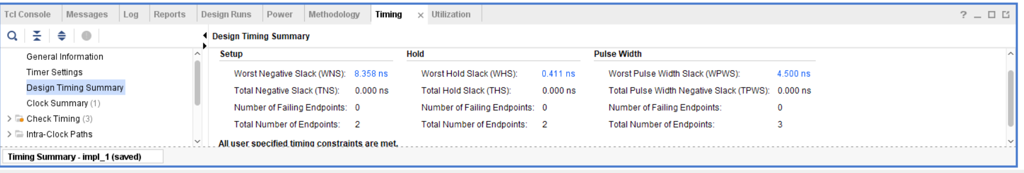

**Linting:**

